ENGLISH FIRST ADDITIONAL LANGUAGE
GRADE 8
16 NOVEMBER 2012
PAPER 3
TIME:1½ hour (11:20-12:55)

INSTRUCTIONS
- This paper consists out of two sections.
- Begin the answer of each Section on a new page.
- Answer ONE question from each Section.
- Indicate the number of words you have used in brackets at the end of your writing.
- Write the number of the question you are doing at the centre top of your writing.

SECTION A – CREATIVE WRITING
Write a creative piece about ONE of the topics below. Use 200 to 250 words.

- My favourite holiday.

- I have to tell you this story….

- Surprise!!!

(30)

SECTION B – TRANSACTIONAL WRITING
Write about ONE of the topics below. Use 120-150 words.

- Write a letter to a friend. In this letter you must explain why you will NOT be able to go on a trip to Namibia with him/her.

- Pretend you are somebody like Nelson Mandela who had to be in prison.Write a diary for one of your days in prison.
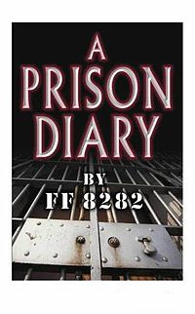
- Pretend your best friend is very famous. Write a magazine article about your best friend.

(20)

